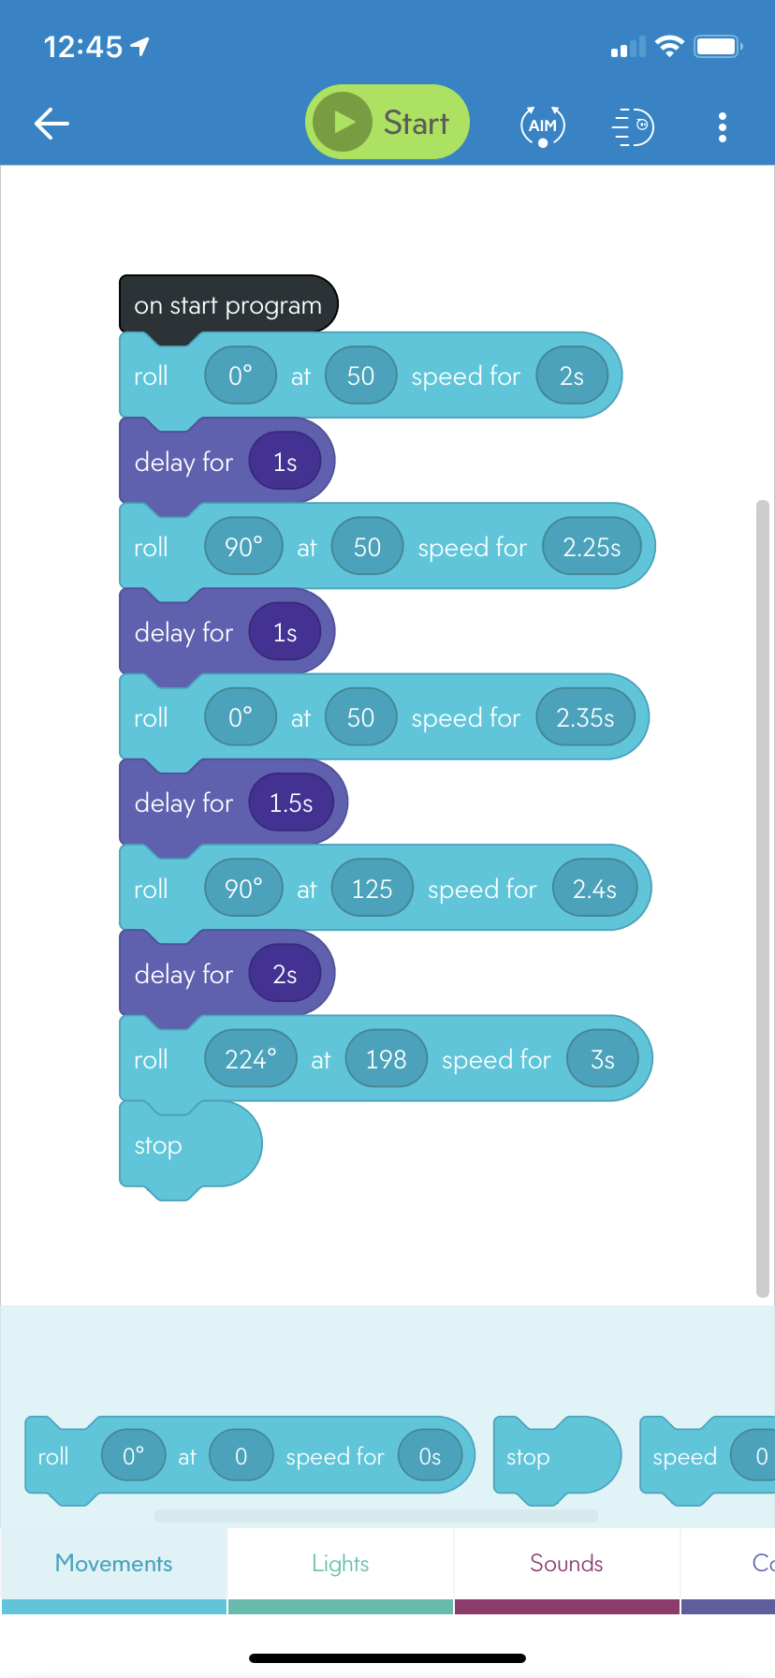

async function startProgram() {

await roll(0, 50, 2);

await delay(1);

await roll(90, 50, 2.25);

await delay(1);

await roll(0, 50, 2.35);

await delay(1.5);

await roll(90, 125, 2.4);

await delay(2);

await roll(224, 198, 3);

stopRoll();

}